# Assignment 2 Guide

# Deleting and Recreating the Database

To delete the database

* ***Run the project*** (SQL Server only runs while the project is running)
* Select ***View => SQL Server Object Explorer***

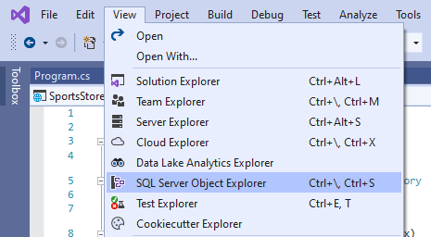

* To delete the database open ***localdb => Databases*** and right click on ***KoalaBeach***
  + If the database is not there right click on ***localdb*** and select ***Refresh*** first
  + ***Right click on localdb (or SQLServer) NOT the white space***
  + If the ***KoalaBeach*** database is not there it was not created
* Right click on ***KoalaBeach*** and select ***Delete***

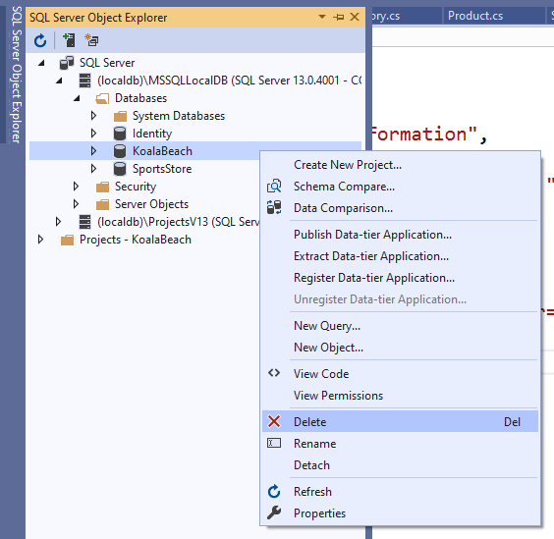

* Check ***Close existing connection***

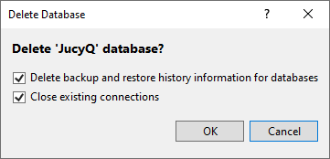

* Simply rerun the project
  + The database will be recreated from the ***Migrations/_Initial.cs*** migration file
  + This will be done by the migration check at the start of the ***SeedData.cs*** file
* With the project running open ***SQL Server Object Explorer*** and check the database
  + If you cannot see the KoalaBeach database, right click on ***localdb*** and select ***Refresh***

## **Database not Created**

If the database is not created (check again that you clicked refresh on localdb (not the whitespace)

* Right click on the ***migrations*** folder in Visual Studio and select ***delete***
* In the PowerShell change to the project folder and run the migration command

**dotnet ef migrations add Initial**

Run the project and check that the database has been created